https://www.marketwatch.com/story/high-gas-prices-and-inflation-are-stressing-people-out-but-the-economy-will-be-fine-as-long-as-they-keep-spending-4f4b66e3?mod=home_lead

FINANCE

High gas prices and inflation are stressing people out — but the economy will be fine as long as they keep spending

The effects of Iran war have been muted so far
By
Jeffry Bartash
Follow
Published: May 16, 2026 at 9:00 a.m. ET
Share
Resize

(6 min)
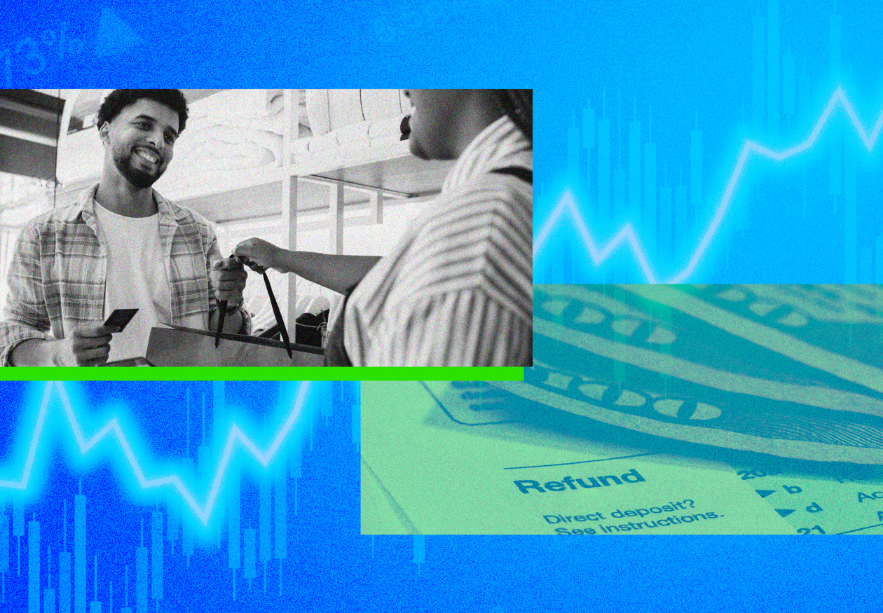The U.S. economy hasn’t been hurt much by the Iran war thanks to consumer spending.Photo: MarketWatch photo illustration/iStockphoto
Nearly three months into the Iran war, Americans are still spending plenty of money to keep the U.S. economy on the up and up. Some signs of stress have emerged, but not enough to suggest a major stumble.
The latest evidence on consumer spending — the main engine of the economy — shows little or no pullback in household purchases since the Iran conflict began at the end of February.
U.S retail sales rose in April at an above-trend pace for the third month in a row, for example, and credit-card spending was particularly strong last month.

Ad Loading
00:00

/
01:35

Ad Loading
00:00

/
01:35

The Stocks That Held up as the Market SlidSee All Videos

“The U.S. consumer is simply remarkable,” said Stephen Stanley, chief U.S. economist at Santander Capital Markets. ”Through thick and thin, consumer spending always seems to hold up in the U.S., regardless of the headwinds that households face. ”
Stable consumer spending, plus a big surge in business investment in artificial intelligence, could lead to robust second-quarter growth based on the official scorecard for the economy known as gross domestic product.
It’s still early in the cycle, but the Atlanta Federal Reserve’s GDPNow forecasting tool predicts 4% growth in the second quarter, double the 2% increase in the first three months of the year.

Wants and needs
A not-insignificant portion of consumer spending, to be sure, is the result of a big jump in gas prices since the conflict with Iran. Higher energy costs have pushed the rate of inflation to a three-year high of 3.8% — and it could go higher still.
The cost of most goods and services, however, haven’t risen that much since the war, save for very visible prices such as gasoline or airline tickets. It takes time for higher energy prices to work their way into every nook and cranny of the economy.
In April, Americans spent a lot of money shopping online or going out to eat for dinner. Internet sales rose more than 1% and restaurant spending was up sharply for the second time in the past three months.
“Clearly, consumers didn’t trim back their Amazon shipments or restaurant trips,” said Thomas Simons, chief U.S. economist at Jefferies.

These are the sorts of purchases — wants, not needs — that are crucial as an economic signal. They rise when Americans feel secure enough financially, and soften when families are under duress.
“Households would not be going out to dinner regularly if they were in serious financial trouble,” Stanley contended. “The decent gains in this category are, in my view, a telltale sign that the consumer feels OK.”
Consumer-behavior analyst Chip West says Americans have responded to higher gas prices by being more selective in what they buy. They search for more deals and discounts, buy in-house brands and use bonus points from loyalty programs.
“Shoppers are frustrated by prices, but they haven’t stopped spending,” said West, director of category strategy at RR Donnelley. “Instead, they’ve become far more strategic and selective.”

Credit or debit?
Credit-card and banking account data also point to resilient consumer spending.
Bank of America Institute said its internal data showed a springy 4% increase in credit-card spending in the 12 months ended in April on all goods and services other than gas.
”With or without gasoline, spending was strong in April,” the institute said.
Some economists disagree. They argue consumers are just running in place; higher inflation means their standard of living isn’t getting any better.
“Dollars might be getting spent, but not much stuff is being bought,” said Neil Dutta, head of economics at Macro Renaissance Research.
Other analysts point to higher credit-card spending as a warning sign that consumers are increasingly stretched, foreshadowing slower spending ahead as higher energy prices and rising inflation sap household finances.
“More consumers are turning to savings and credit to sustain spending,” wrote economists Gregory Daco and Lydia Boussour of EY Parthenon. “These trends are becoming increasingly difficult to maintain, particularly for lower-income households.”

‘K-shaped’ economy
Bank of America Institute concurred that lower-income households are feeling more stress and cutting back.
Yet it also noted bank deposits are in good shape, credit-card usage is at safe levels and only about half of all tax refunds have been spent.
“Households have some near-term buffers to support their spending,” the institute said.
A low unemployment rate and near-record-low level of layoffs are also big pillars of support for further spending, as people spend more when they feel secure in their jobs.
Still, the split between higher- and lower-income families is one of the chief worries of economists — what they refer to as a “K-shaped” economy.
Wealthier Americans are doing fine: A powerful bull market in stocks has created scores of 401(k) millionaires, and their homes are worth a small fortune. Upper-income people also own a larger share of electric vehicles and hybrids, and don’t spend as much on gas.
Lower-income families living from paycheck to paycheck have far less of a financial cushion, if any at all. The longer gas prices remain high, the worse it will get, since they spend a bigger share of their income on fuel and transportation costs.
Eventually, these strains could be enough to depress the economy, especially if interest rates keep rising. Richer Americans can’t carry the economy by themselves indefinity —there is not enough of them.
“Wealth effects and personal income-tax cuts continue to prop up American consumer spending, but rising inflation and elevated longer-term interest rates could begin to weigh more heavily,” said Sal Guatieri, senior economist at BMO Capital Markets.

